# CS 255 System Design Document Template

## UML Diagrams

### UML Use Case Diagram

### UML Activity Diagrams

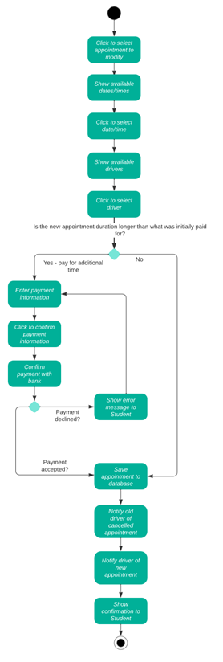

### UML Sequence Diagram

### UML Class Diagram

## Technical Requirements

In terms of hardware, the system will be run in a cloud-based web environment. This means that all the data required for the system will be stored online, and that the system itself will be accessible via the web using a unique website address. The system will require a database to save and retrieve information, such as customer accounts and their driving appointments.

Since this system is intended to be run in the browser, the front-end of the website will be written using JavaScript and the library React.js. This will require various tools such as a code editor and a command line interface. The back-end of the system will also be written using JavaScript.

In order to secure the website, the system must be issued an SSL certificate which will enable encryption for the data passing between the user and the system.